Project Report
Cosmetic Insights: Navigating Cosmetics Trends and Consumer Behavior with Tableau

Field | Details
Team Lead | Govindu Kavya Sri
Team Members | Eswari Gayatri Budumuru, Kiladi Kalavathi, Adaka Mounika, Panditi Jyostna
Domain | Retail / Cosmetics Analytics
Tools Used | Python, Microsoft Excel, Tableau Public
Dataset | Cosmetics product dataset — 1,472 records, 11 attributes
Published Dashboard | public.tableau.com/app/profile/govindu.kavya.sri/viz/cosmeticproject_17872016666220/Dashboard1

Project Context
The cosmetics industry is one of the fastest-growing and highly competitive sectors, driven by changing consumer preferences, diverse skin types, brand innovation, and evolving pricing strategies. With increasing demand for personalized beauty products, companies rely on data-driven insights to understand market trends, consumer behavior, and product performance.
This project, “Cosmetic Insights: Navigating Cosmetics Trends and Consumer Behavior with Tableau,” focuses on analyzing a cosmetics dataset to uncover meaningful patterns and actionable insights. The dataset includes key attributes such as brand, product category, price, rank, and skin type suitability (Dry, Oily, Combination, Normal, and Sensitive).
This project is designed to help businesses and analysts understand cosmetics market trends and consumer preferences. By analyzing brand performance, pricing patterns, product distribution, and skin-type coverage, the dashboard enables stakeholders to identify high-performing products, target specific customer segments, and optimize marketing and product strategies.

Scenario 1: Monitoring Consumer Preferences
In a real-time scenario, imagine receiving an alert indicating a concerning trend in consumer preferences, such as a significant decline in interest in certain cosmetic products or ingredients. Using the Cosmetic Insights data, we can promptly assess the extent and potential impact of this trend, identify contributing factors, and deploy immediate interventions to adapt product offerings and marketing strategies. Whether it's through targeted promotional campaigns, adjustments in product formulations, or personalized recommendations, real-time analysis enables agile decision-making and proactive measures to meet evolving consumer needs.

Scenario 2: Addressing Product Concerns
In the event of identifying widespread product concerns, such as negative reviews or safety issues associated with specific cosmetic items, real-time access to Cosmetic Insights data enables swift response and management. Cosmetic companies and regulatory bodies can utilize the dataset to gather crucial information about the concerns, including their prevalence, potential impacts on consumer trust, and affected product demographics. By leveraging real-time analytics, they can implement quality control measures, recall products if necessary, and communicate transparently with consumers to address their concerns and maintain brand integrity.

Scenario 3: Predictive Analysis and Product Innovation
Leveraging predictive analytics capabilities, Cosmetic Insights empowers companies to anticipate and respond to emerging trends and consumer preferences in the beauty industry. By analyzing historical data and identifying predictive indicators, companies can proactively innovate new products, adjust existing formulations, and tailor marketing strategies to meet evolving consumer demands. Real-time monitoring of market trends, consumer feedback, and competitor activities enables timely interventions, product innovation, and strategic decision-making to stay ahead in a competitive market landscape.

Contents
- Introduction — Project Overview, Purpose
- Ideation Phase — Problem Statement, Empathy Map Canvas, Brainstorming
- Requirement Analysis — Customer Journey Map, Solution Requirements, Data Flow Diagram, Technology Stack
- Project Design — Problem–Solution Fit, Proposed Solution, Solution Architecture
- Project Planning & Scheduling
- Functional and Performance Testing
- Results — Output Screenshots
- Advantages & Disadvantages
- Conclusion
- Future Scope
- Appendix

1. Introduction

1.1 Project Overview
Cosmetic Insights: Navigating Cosmetics Trends and Consumer Behavior with Tableau is a team Tableau business intelligence project built on a cosmetics product dataset covering 1,472 products across 6 categories and 116 brands. The raw dataset was cleaned in Python (Pandas) before being connected to Tableau, where four worksheets and one interactive dashboard were built and published to Tableau Public for free, browser-based, authentication-free access.
The project was led by Govindu Kavya Sri (Team Lead), with team members Eswari Gayatri Budumuru, Kiladi Kalavathi, Adaka Mounika, and Panditi Jyostna, as part of the SkillWallet Data Analytics with Tableau Program.

1.2 Purpose
The purpose of this project is to turn a raw, unfiltered cosmetics product catalog into an accessible decision-support tool for three distinct audiences: skincare consumers comparing price against rating and skin-type fit, retail category managers planning pricing and assortment, and brand marketing analysts benchmarking competitive positioning. Each audience is served by the same interactive dashboard, explored through cross-chart filtering and a searchable brand filter rather than three separate static reports.

2. Ideation Phase

2.1 Problem Statement
Problem statements were derived from three personas using an “I am / I'm trying to / But / Because / Which makes me feel” framework (see Define the Problem Statements document for the full table).

Key Takeaway
All three personas are blocked by the same root cause: cosmetics product data exists but is not accessible or visual. This shared root cause justified a single Tableau solution serving all three audiences rather than three separate tools.

2.2 Empathy Map Canvas
The empathy map was built for Priya, the skincare consumer, whose constraints (fixed budget, sensitive skin, no trusted comparison source) map most directly onto the dashboard's core charts. The pains-to-gains mapping shaped two concrete design decisions: the Price vs Rating scatter chart exists to directly test the price-equals-quality assumption, and the Skin Type Coverage heatmap exists to confirm suitability before purchase.

2.3 Brainstorming, Idea Generation & Prioritization
Selected problem: “How can we help consumers, retailers, and brand analysts compare cosmetics products by price, rating, brand, and skin-type suitability using historical product data?” The four ideas prioritized for the first release — price-by-category, price-vs-rating, top-brands-by-category, and skin-type coverage — together answer the core questions of all three personas without overlapping.

3. Requirement Analysis

3.1 Customer Journey Map — Priya (Skincare Consumer)
The emotional curve dips lowest at Awareness/Consideration, then climbs as Priya reaches Onboarding and Usage — confirming that a clean first chart and responsive cross-chart filtering are the difference between abandonment and a confident purchase decision. Two requirements were added directly from this map: cross-chart filter actions (FR-10) and a searchable Brand filter (FR-05).

3.2 Solution Requirements
Fourteen functional requirements (data connectivity, cleaning, reshaping, four charts, filters, dashboard assembly, tooltips, and publishing) and eight non-functional requirements (usability, performance, reliability, scalability, availability, security, cost, and compatibility) were defined and verified against the shipped workbook — see the Solution Requirements document for the full tables.

3.3 Data Flow Diagram
- Step 1 — Raw Source: cosmetics.csv (1,472 rows, 11 columns)
- Step 2 — Data Cleaning: Python (Pandas) standardizes brand casing, replaces ingredient placeholders, converts zero-ranks to missing, renames skin-type columns
- Step 3 — Cleaned Dataset: cosmetics_cleaned.xlsx loaded into Tableau
- Step 4 — Tableau Data Source: Excel connected; field types verified
- Step 5 — Data Reshaping: five skin-type columns pivoted into Skin_Type / Suitable (1,472 → 7,360 rows)
- Step 6 — Visualization Layer: four chart sheets built
- Step 7 — Dashboard Layer: single dashboard assembled with cross-chart filter actions and Brand filter
- Step 8 — Publishing: workbook saved to Tableau Public; shareable URL generated

3.4 Technology Stack
The stack was chosen to minimise cost and setup friction: Python/Pandas for local, version-friendly data cleaning, and Tableau Public for free, no-login, browser-accessible visualization and hosting — see the Technology Stack document for full component and characteristic tables.

4. Project Design

4.1 Problem – Solution Fit
Each identified user pain maps directly to a dashboard feature: an unfilterable spreadsheet export becomes an interactive dashboard, a single category average becomes a filterable bar chart, and a static file becomes a shareable Tableau Public link requiring no login — see the Problem–Solution Fit document for the full table.

4.2 Proposed Solution
An interactive Tableau dashboard combining Avg Price by Category, Price vs Rating, Top Brands by Category, and Skin Type Coverage into one cross-filterable view, published on Tableau Public for free browser access.

4.3 Solution Architecture
The end-to-end pipeline follows a linear BI workflow: raw CSV → Python/Pandas cleaning → Tableau data connection → skin-type pivot → four-worksheet visualization layer → single dashboard layer with filter actions and Brand filter → Tableau Public publishing — see the Solution Architecture document for the full seven-layer breakdown.

5. Project Planning & Scheduling
Work was organized across three sprints against the eight epics tracked on the SkillWallet platform. Velocity: Sprint 1 = 8 points | Sprint 2 = 14 points | Sprint 3 = 14 points | Total = 36 story points. Sprint 2 carried the heaviest per-task load, covering both chart-building and dashboard assembly — the most integration-heavy deliverables — see the Project Planning document for the full backlog table.

6. Functional and Performance Testing
All eight performance test cases passed with no defects logged — covering data load, the skin-type pivot, category and brand filter response time, scatter-plot rendering, cross-browser compatibility, published-link accessibility, and filter reset. See the Performance Testing document for the full results table.

7. Results

7.1 Output Screenshots
Live on Tableau Public: public.tableau.com/app/profile/govindu.kavya.sri/viz/cosmeticproject_17872016666220/Dashboard1

Individual Worksheets
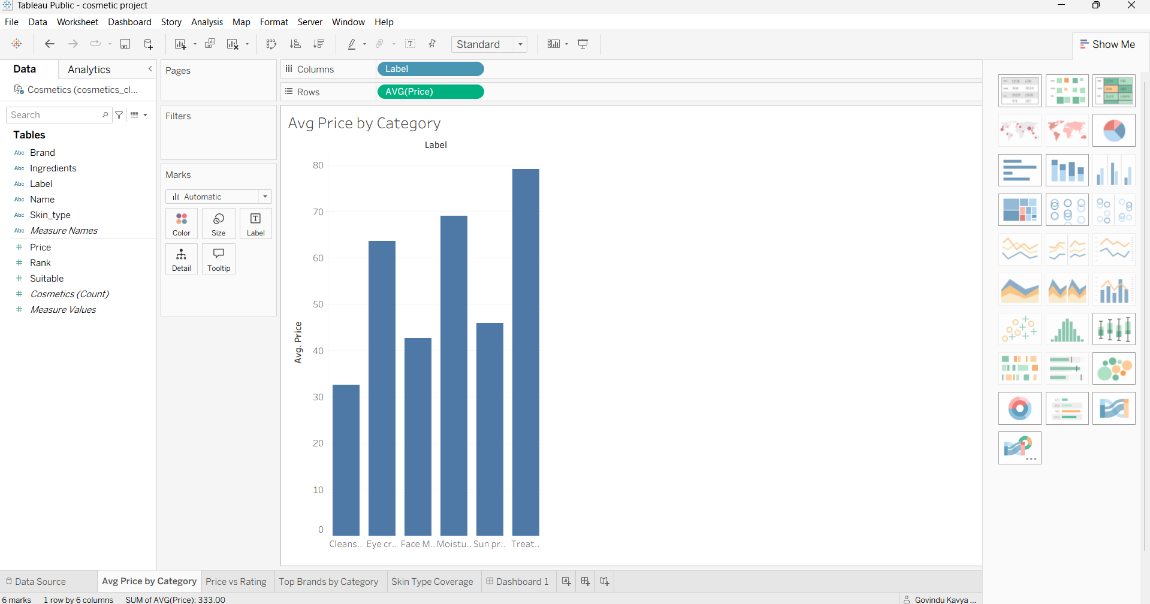
Chart 1 — Avg Price by Category
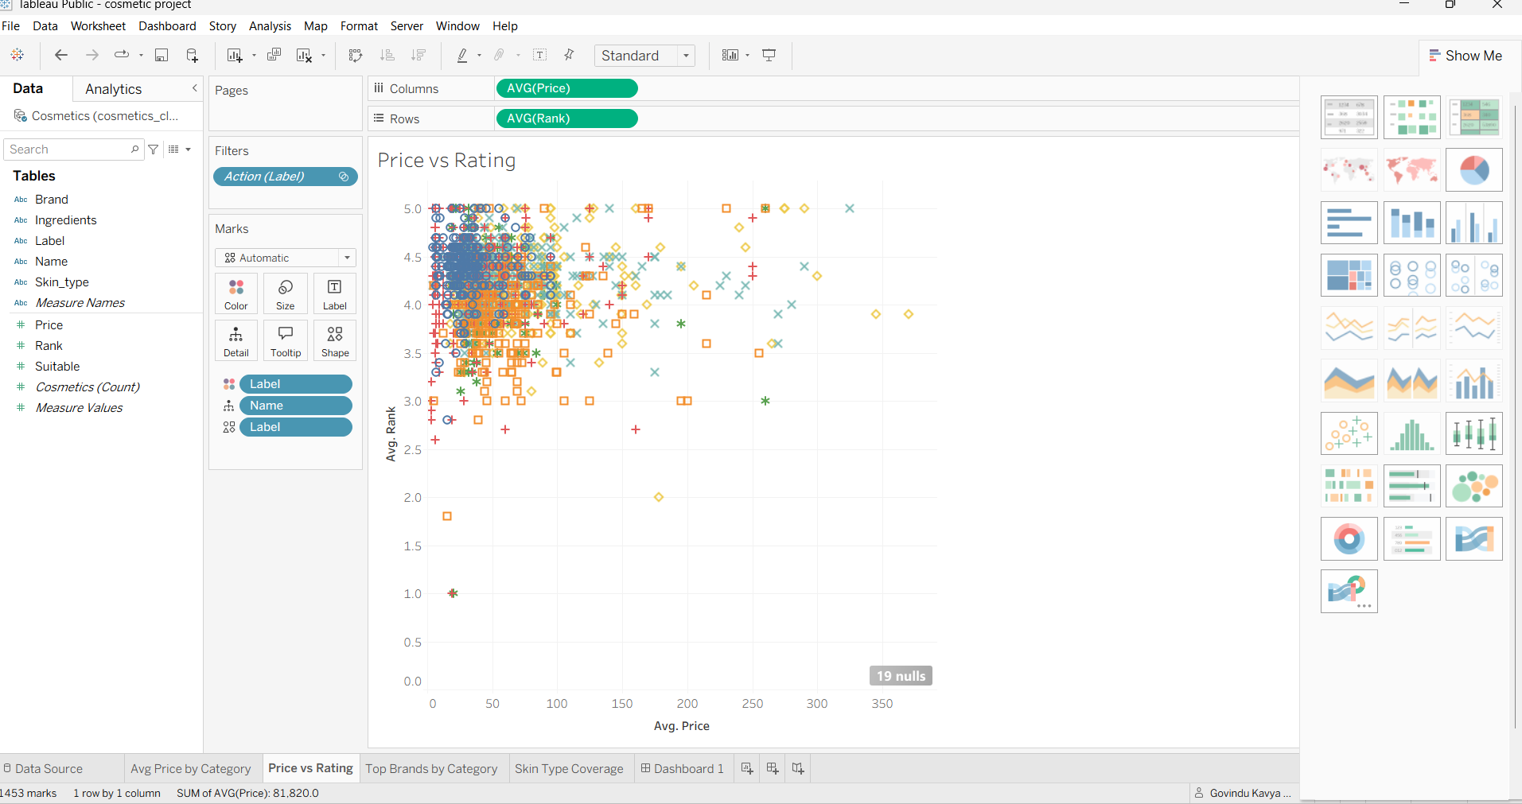
Chart 2 — Price vs Rating
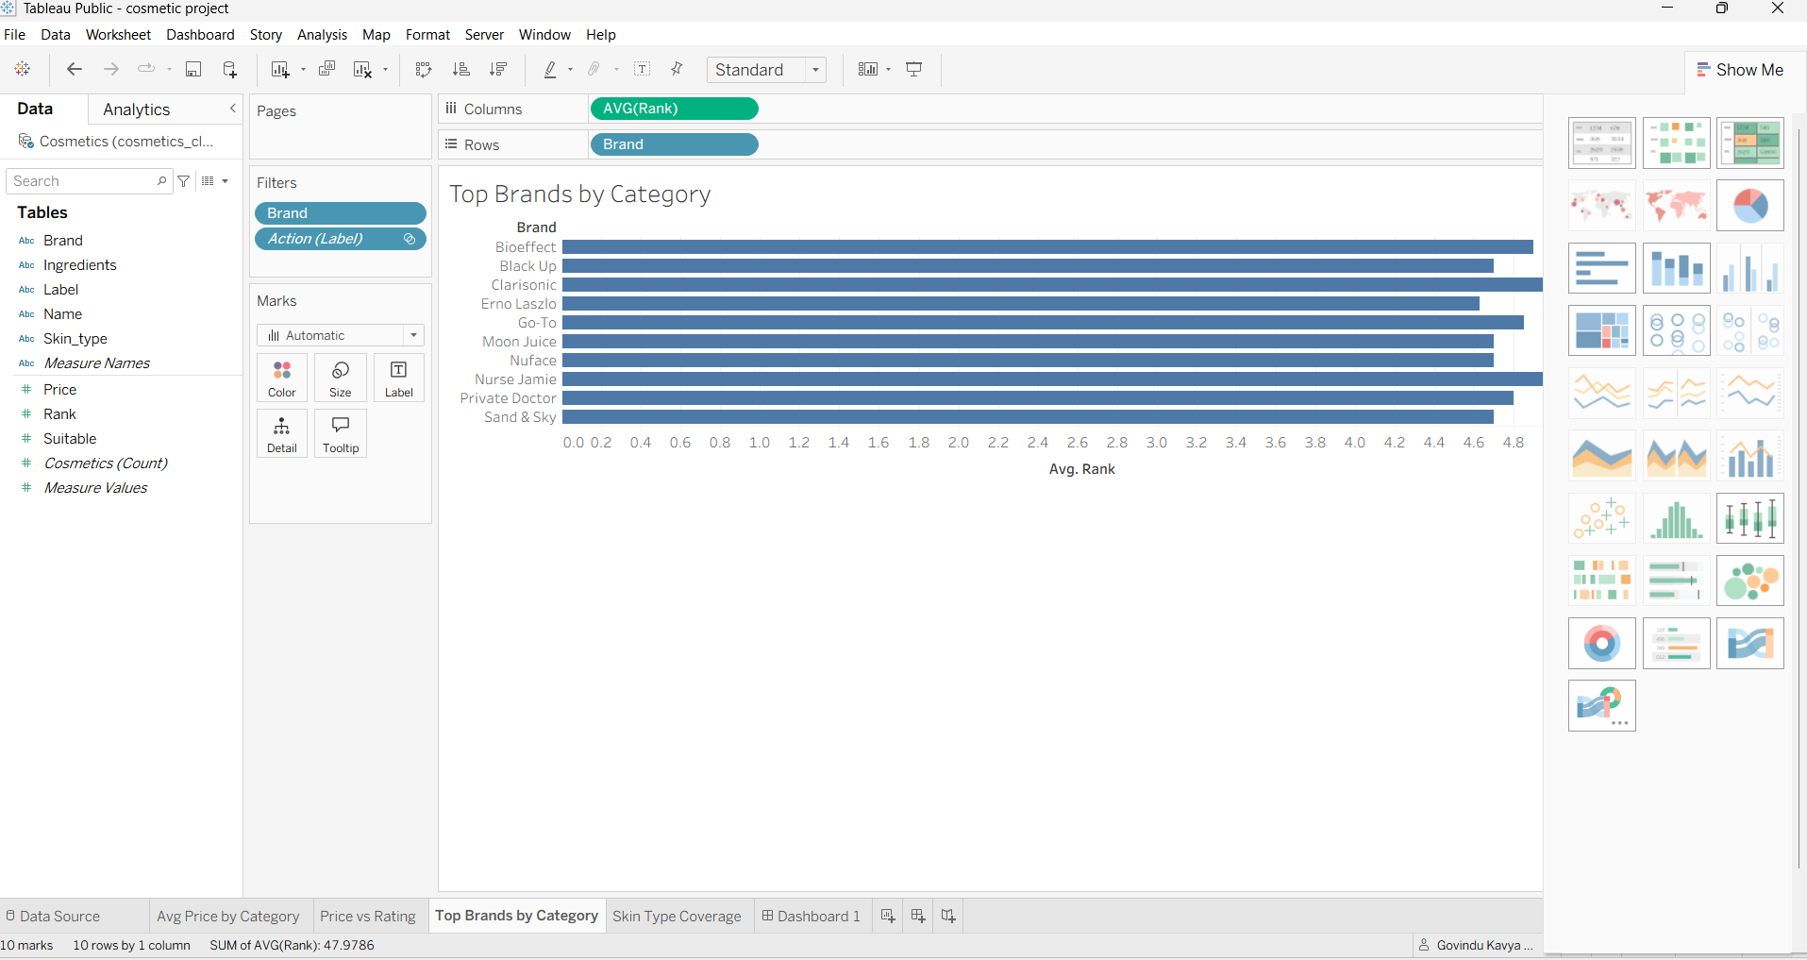
Chart 3 — Top Brands by Category
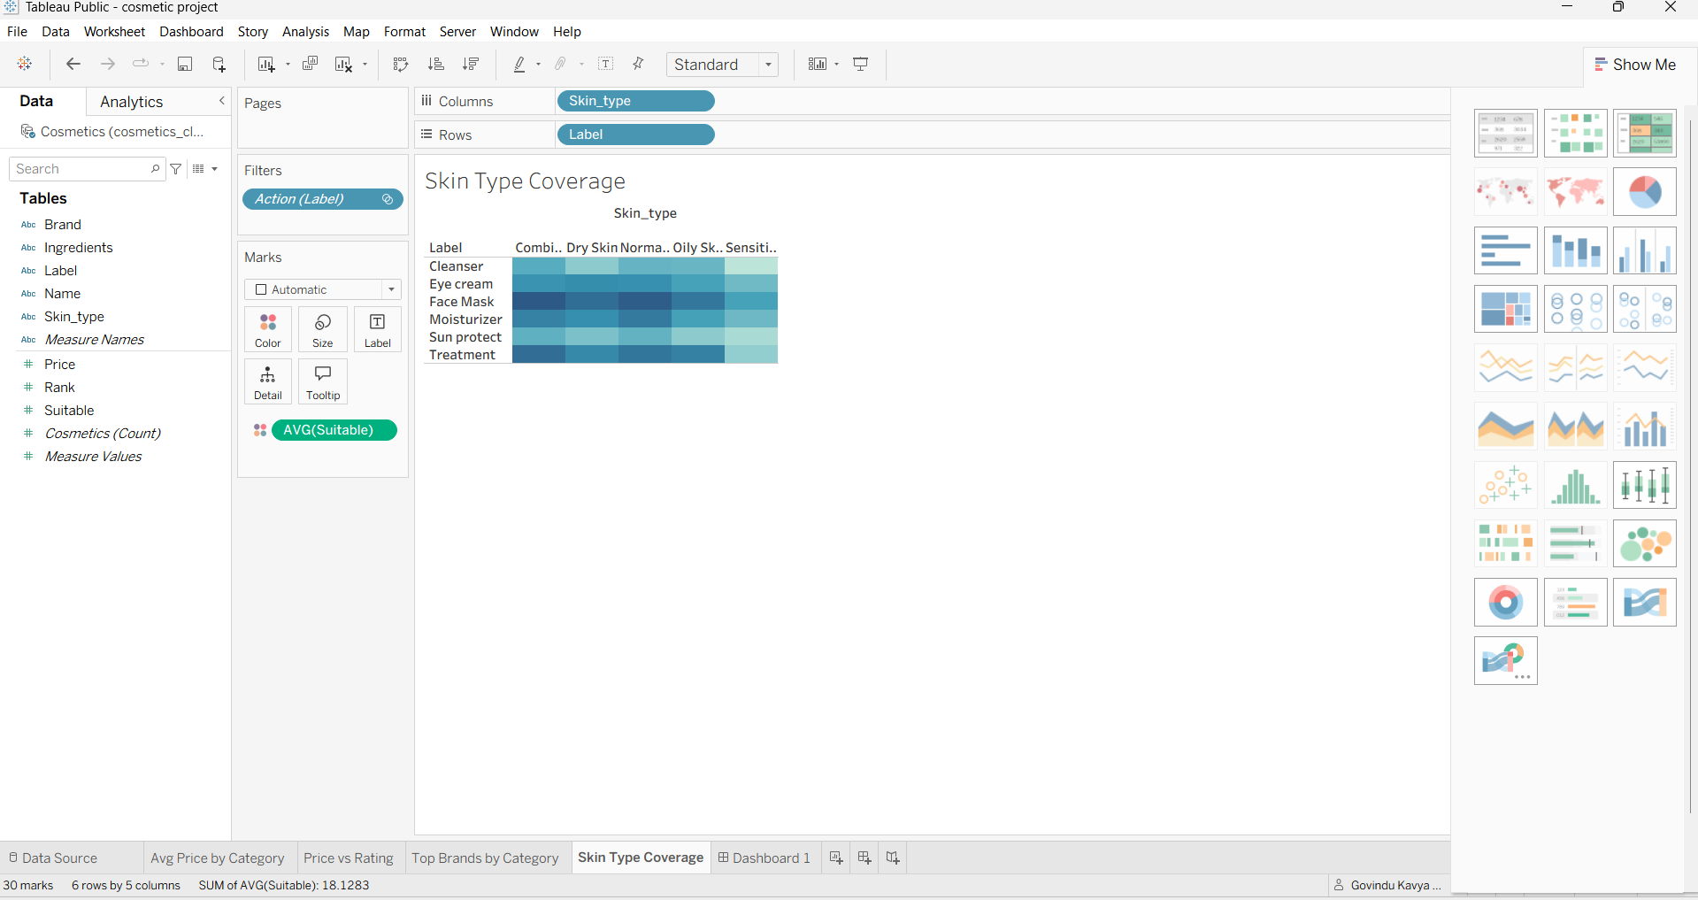
Chart 4 — Skin Type Coverage

Combined Dashboard
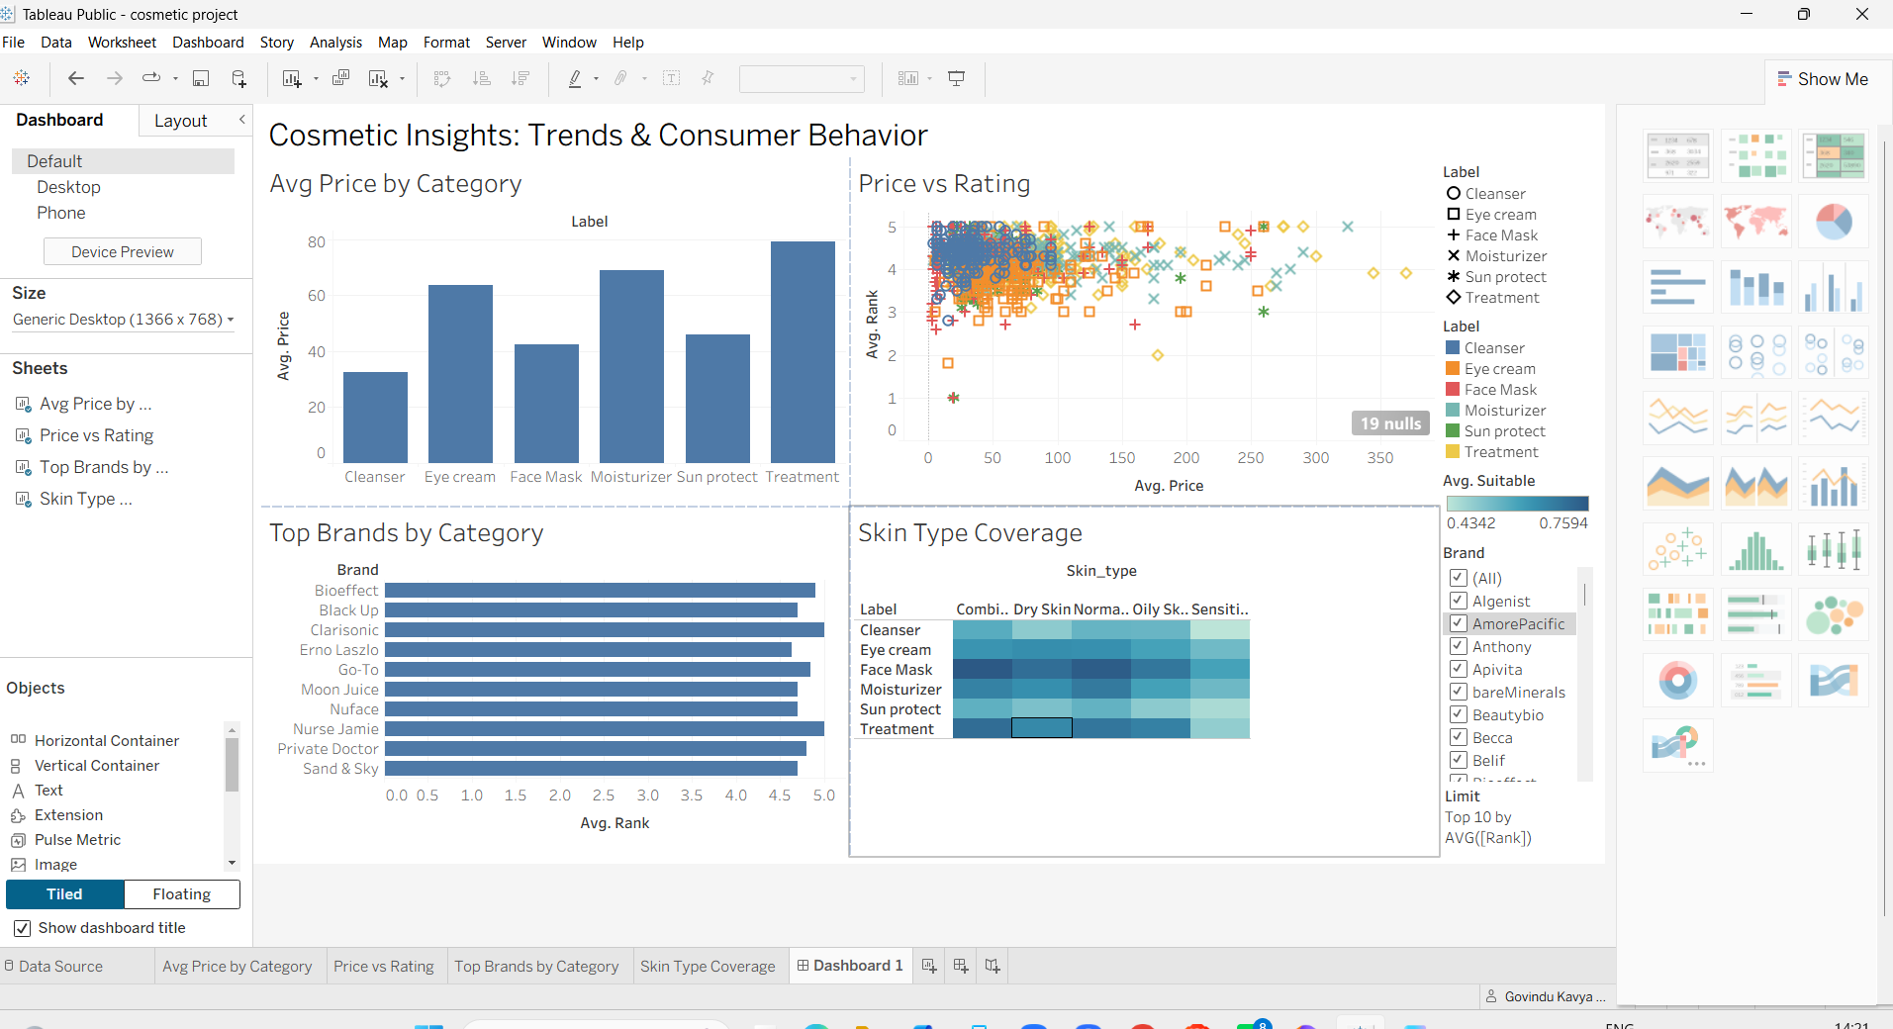
Dashboard 1 — Cosmetic Insights: Trends & Consumer Behavior (Tableau Desktop editing view)
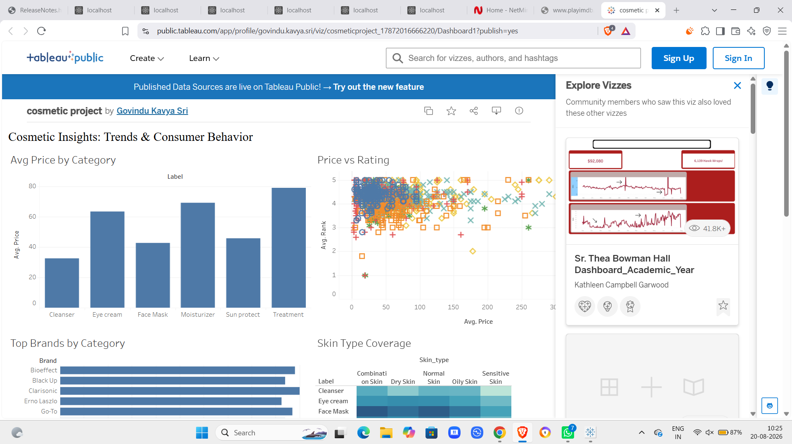
Dashboard 1 as published live on Tableau Public

8. Advantages & Disadvantages

Advantages
- Zero-cost deployment: every tool in the stack (Python, Tableau Public) is free, with no server, license, or IT approval required
- A single dashboard serves three distinct personas through cross-chart filtering rather than three separate reports
- Sub-2-second filter response, confirmed by Performance Testing, with no extraction or aggregation needed
- No login barrier: the public Tableau link is accessible on any browser
- Cross-browser and mobile-view compatibility, validated in Chrome, Edge, and Safari
- Clear traceability from persona pain points through requirements to shipped charts

Disadvantages
- Ingredients text is unstructured; no ingredient-level analysis was performed in this phase
- Rank is an aggregate rating without visible review counts, so lightly-reviewed products are weighted equally with heavily-reviewed ones
- The dataset is a static snapshot rather than a live, continuously refreshed feed
- Tableau Public workbooks are visible to anyone with the link, appropriate here since the dataset is public, but unsuitable for sensitive data
- As with any small-team project, edge cases outside the eight tested scenarios in Section 6 are not formally verified

9. Conclusion
This project successfully converts a raw, unfiltered cosmetics product dataset into an interactive, persona-aware Tableau Public workbook. By tracing every chart back to a specific persona pain point identified during Ideation, and validating every functional and non-functional requirement during Performance Testing, the finished dashboard gives a consumer, a retail category manager, and a brand analyst each a way to answer their own question — without installing software, logging in, or interpreting raw spreadsheet data. All eight performance test cases passed with no defects, and the workbook is publicly available via Tableau Public.

10. Future Scope
- Incorporate ingredient-level analysis (e.g., most common active ingredients by rating tier) using the existing Ingredients field
- Add a price-tier segmentation (Budget / Mid / Premium / Luxury) as a calculated field for more granular comparison
- Build a predictive model to estimate expected rating from price, category, and ingredient features
- Extend the dataset with additional retailers or a larger product catalog to broaden brand and category coverage
- Build a dedicated multi-point Tableau Story as a guided narrative layer over the existing dashboard
- Deploy on Tableau Server or Cloud for enterprise-grade access control and scheduled data refresh if adopted by a retail partner

11. Appendix

Source Code
The Python (Pandas) preprocessing script used to clean the raw cosmetics.csv extract into cosmetics_cleaned.xlsx was developed and run as part of this project's Data Preparation epic.

Dataset
Cosmetics product dataset — cosmetics_cleaned.xlsx, 1,472 rows, 11 original columns (expanded to 7,360 rows / 9 columns after the Skin_Type pivot), covering 6 product categories and 116 brands.

Tableau Public Link
public.tableau.com/app/profile/govindu.kavya.sri/viz/cosmeticproject_17872016666220/Dashboard1

